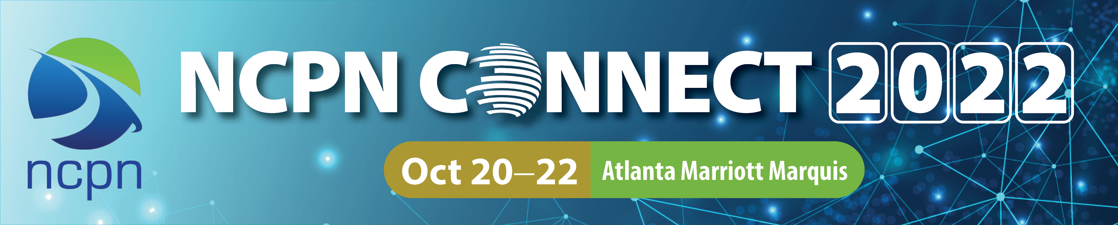CALL FOR PROPOSALS

Dear Colleague,
Thank you for your interest in presenting at 2022 NCPN Connect. Below is a list of items you will need in order to complete the proposal form.
Thanks,
Claudia Maness, NCPN Director
Sheila Wilson, Conference Manager/Chair

Key Presenter Information
Registration fee: All presenters are required to register at the discounted presenter rate of $550 by September 5.
Please do not register until you have been notified that your presentation has been accepted.
Need all contact information on key presenter.

Program Strands
Please select all that apply.
Strand 1
Career Counseling, Development, and Advising
- Career awareness/exploration/development
- Career coaching/navigating
- Career counseling
- College and career planning
- Family engagement
- Growing leaders
- Pathways advising
- Recruitment and retention strategies
- Supporting special populations
Strand 2
Teaching and Learning
- Ability to benefit
- Contextualized instruction
- Co-planning/co-teaching
- CTE program options
- Curriculum alignment
- Diversity, equity, and inclusion
- Integrated education and training (IET) best practices
- Work-based/experiential learning opportunities
- Essential/employability/soft skills
Strand 3
Designing / Delivering Programs
- Adult career pathways
- Apprenticeships/pre-apprenticeships
- Competency-based education
- Credentialing
- Credit for prior learning/prior learning assessment
- Design/deliver Career Pathways programs
- Diversity, equity, and inclusion
- Dual and articulated credit
- Guiding learning pathways
- Industry-recognized certifications
- Internships
- Measurable skill gains
- Pathway mapping
- Scholarships
- Stackable credentials
Strand 4
Establishing / Growing Partnerships
- Building cross-agency partnerships
- Classroom speakers/mentors
- Dual and articulated credit
- Employer engagement
- Examining equity through Career Pathways
- Measuring impact
- Relationship management
- Policy and program alignment
Strand 5
Workforce Development
- Correctional models
- Diversity, equity, and inclusion
- Essential/employability/soft skills
- Programs to support returning veterans
- Using labor market data
- Talent development strategies
- WIOA administration to support pathways
- Workforce board partnerships

Title of Presentation *
Maximum: 12 words. The title should clearly communicate what the presentation is about.
Description of Presentation *
Maximum: 50 words. Describe what conference attendees can expect to learn from your session, how they will benefit from it, and what they will take home. Be sure Your presentation is geared toward a national audience. This description will appear in the conference program book. Priority will be given to presentations that are engaging / interactive and have takeaways for attendees. Be sure your description accurately describes your presentation.
Abstract *
Maximum: 100 words. Give a brief summary of what you plan to accomplish in your session and how you will present it. Tell what attendees will take home and implement. This information will not be published and is used only for evaluating presentations.
Room Setup *
Select one.
- Theater (rows of chairs)
- Banquet (round tables)
Presentation Length Preferred *
-45-minutes
-One hour
Please check which presentation length you prefer. Although we cannot guarantee that you will be scheduled according to your preference, if you are accepted, NCPN will make every effort to schedule your session accordingly.
Will this session be presented in panel format? * Will you need head tables with microphones for your panelists?
Audiovisual Equipment
An LCD projector, Internet, screen, sound for laptop, and microphone (as needed) will be provided in each meeting room. Bring your own laptop. NCPN does NOT provide laptops.
Expected Audience Size *
Please estimate. Room assignments are based on availability.
-25
-50
-100
Audience Level
Check all that apply.
-Secondary
-Postsecondary
-Adult Education
-Workforce Development
-Business
Audience Position
(Check all that apply.)
-Faculty
-Counselor
-Administrator
-Staff
-Employer
Content Level *
-Beginner
-Intermediate
-Advanced

Will your session promote a product or service that is commercially available from you or a company that you represent? *
List one major conference where you have presented within the last 3 years.

Reference Information
Please provide the name and contact information for someone who can attest to the quality of your proposed session and presentation skills.
Name of Reference*
Reference Phone *
Reference Email *

All presenters are required to register for the conference and pay the discounted presenter registration fee of $550 by Sept. 5.
Presenters should wait to register until they have received notification that their presentation has been selected on May 16.
Co-presenters:
Do you have any co-presenters? Need contact information on each co-presenter.
I agree to present in any time slot to which I'm assigned on Friday or Saturday.
I understand that I (and additional presenters, if applicable) am responsible for my own travel arrangements, hotel expenses, and applicable registration fees.
Travel arrangements should not be made until you have been assigned a presentation time slot in July.

